Supplementary Data
Raltegravir plasma exposure: A Machine Learning-Based Model for its Prediction Using Limited Sample Strategy
Matheus De Lucca Thomaz^{1#}; Kathley Lanna Rezende de Azevedo^{2#}; Tiago Antunes Paz^{1#}; Glauco Henrique Balthazar Nardotto³; Fernanda de Lima Moreira⁴; Geraldo Duarte²; Jean-Baptiste Woillard⁵; Vera Lucia Lanchote¹; Joao Paulo Bianchi Ximenez¹
¹School of Pharmaceutical Sciences of Ribeirao Preto, University of Sao Paulo, Ribeirao Preto, SP, Brazil
²Ribeirao Preto Medical School, University of Sao Paulo, Ribeirao Preto, SP, Brazil
³Department of Pharmacology and Therapeutics, Roswell Park Comprehensive Cancer Center, Buffalo, NY, US
⁴Faculty of Pharmacy, Federal University of Rio de Janeiro, Rio de Janeiro, RJ, Brazil
⁵Department of Pharmacology, Toxicology and Pharmacovigilance, CHU de Limoges, Limoges, France

Feature engineering
Feature importance was initially evaluated with Random Forest(1) (regression mode, 500 trees), GLMNet(2) (regression, LASSO setting, mixture = 1), and Boruta(3) feature selection, followed by importance plots. Supplement Table 1 presents the features importance when Boruta analysis was performed, where it shows the C4, C3 and C0 were the 3 most important features to determine AUC₀₋₁₂. Supplement Figures 1 and 2 show the importance of the concentrations, their ratios and subtractions, and covariates, when Random Forest, trees = 500, and GLMNet, mixture and penalty = 1, settings were evaluated to predict AUC₀₋₁₂.
In order to analyse the best possible combination of timeframes and the selection of features to be added, the following algorithms were initially applied to all concentrations and covariates in our dataset, then tested each result and their overlap: Boruta¹, developed based on Random Forest. This is an ensemble method where classification is performed by "voting" among multiple decision trees (unbiased weak classifiers), each trained on random subsets of the data. The importance of each attribute is calculated by measuring the loss in accuracy when its values are randomly permuted. This metric is computed for all trees that use the attribute, with the final importance given by the average impact (or by the Z-score, obtained by dividing the mean by the standard deviation of the losses); GLMNet, which consists of generalized linear models and similar approaches via penalized maximum likelihood, using LASSO regularization (L1, mixture = 1). The algorithm employs cyclic coordinate descent, iteratively optimizing the objective function for each parameter individually (while keeping the others fixed) until convergence is reached. Features deemed irrelevant have their coefficients zeroed out; Random Forest with its default settings.
As a result of the feature selection, we obtained the three most important features from each methodology: C0, C2, C3, and C4, with no significant importance observed for fixed predictors such as WT, ATV, EFV, LOWFAT, FED, and PREG. The ML models were then trained using only combinations of these concentrations (2-by-2, pairs, and 3-by-3, triplets). However, the observed results were unsatisfactory, showing high imprecision and bias. Since the results from feature selection were not satisfactory, an extensive analysis was carried out of all combinations of pairs and triplets of concentration times with the inclusion or not of covariates and derived predictors (ratios and subtractions), in which only the concentrations C0.5, C2 and C4 were included in the final model.

SUPPLEMENTARY TABLE AND FIGURE LEGENDS
Supplement Table 1 - Boruta analysis of features importance
Supplement Table 2 - Optimized hyperparameters for the final machine learning model

Supplement Figure 1 - Importance plot using Random Forest basic settings, evaluating the weight of all concentrations, their ratios and subtractions, and covariates
Supplement Figure 2 - Importance plot using GLMNet basic settings, evaluating the weight of all concentrations, their ratios and subtractions, and covariates

TABLES
Supplementary Table S1
Feature | Mean Importance | Median Importance | Min Importance | Max Importance
C4 | 15.64902646 | 15.63621235 | 13.9710969 | 17.196031
C3 | 15.23259305 | 15.33930547 | 13.1284907 | 16.532281
C0 | 14.60778728 | 14.82592333 | 9.4150803 | 17.078687
C3-C0 | 13.69609757 | 13.74218922 | 11.3796079 | 14.777301
C3/C0 | 13.21307706 | 13.54086493 | 4.4567564 | 15.479623
C2 | 13.1810675 | 13.19658994 | 11.3028818 | 15.150189
C4-C0 | 12.81180172 | 12.86008925 | 11.561345 | 14.152892
C4/C0 | 12.69185049 | 12.85932501 | 7.0076183 | 15.028403
C2/C0 | 12.24319266 | 12.45617085 | 8.6954924 | 14.81445
C2-C0 | 12.1179225 | 12.18490345 | 10.3104184 | 13.378902
C4-C2 | 9.70090254 | 9.770673676 | 7.2289205 | 11.578897
C1 | 9.62739025 | 9.607635504 | 7.8411978 | 11.833419
C1/C05 | 9.56101027 | 9.435670273 | 5.0128734 | 12.781915
C1-C0 | 9.55489697 | 9.592592995 | 5.4445594 | 12.082542
C1/C0 | 9.37609788 | 9.568900686 | 5.3174401 | 11.505533
C4-C1 | 9.30297279 | 9.239359537 | 5.4618718 | 12.715288
C05 | 9.07978611 | 8.973848262 | 6.5777701 | 12.118914
C4-C3 | 8.5798184 | 8.584594109 | 6.2063298 | 10.198803
C2/C05 | 8.55229179 | 8.581385327 | 4.4074697 | 11.115346
C4-C05 | 8.13213379 | 8.170847527 | 5.5724933 | 10.075827
C4/C2 | 8.07673816 | 8.122113765 | 5.1340474 | 10.506249
C3-C2 | 7.9061332 | 8.120447079 | 4.661268 | 9.269257
C05-C0 | 7.89102251 | 7.82963969 | 4.5304092 | 10.618504
C3/C05 | 7.80545056 | 7.946052119 | 3.9820311 | 10.578518
C2-C05 | 7.55370681 | 7.73657936 | 4.2747609 | 9.067343
C3-C1 | 7.47338704 | 7.531072896 | 4.1854052 | 10.42855
C4/C05 | 7.17463093 | 7.359370497 | 3.3858247 | 9.362688
C3-C05 | 7.06541298 | 7.125424851 | 4.8526905 | 9.659801
C4/C3 | 7.06062999 | 7.288456121 | 4.0067502 | 9.572526
C2/C1 | 6.97436104 | 7.149248351 | 2.8169499 | 9.924845
C4/C1 | 6.93221139 | 6.94290001 | 4.3614245 | 10.004431
C1-C05 | 6.86117907 | 7.109542764 | 4.0791745 | 8.534496
C05/C0 | 6.54679066 | 6.530882968 | 3.8343834 | 8.203813
C3/C1 | 6.24957158 | 6.347986921 | 3.5415652 | 9.2567
C3/C2 | 6.18282781 | 6.183225008 | 3.5609677 | 7.939149
C2-C1 | 5.92982276 | 5.943292497 | 3.1478425 | 8.028543
PREG | 2.26424983 | 2.302571136 | 1.0651585 | 3.327074
LOWFAT | 2.15038924 | 2.253831962 | 0.7149983 | 3.396567
FED | 1.34748157 | 1.458492214 | -0.3282263 | 2.487662
ATV | 0.21088206 | 0.174675065 | -0.7623822 | 1.017576
WT | 0.20794654 | -0.003270604 | -1.586932 | 2.785777
EFV | -0.07613134 | -0.35606693 | -1.4979762 | 1.262684

Supplementary Table S2
mtry | trees | min_n | tree_depth | learn_rate | sample_size
2 | 1864 | 4 | 9 | 0.0078 | 0.2373
Mtry, number of predictors that will be randomly sampled at each split when creating the tree models; trees, number of trees contained in the ensemble; min_n, the minimum number of data points in a node that is required for the node to be split further; tree_depht, maximum depth of a tree, number of splits; learn_rate, rate at which the boosting algorithm adapts from iteration-to-iteration; sample_size, proportion of data that is exposed to the fitting routine

FIGURES
Supplementary Figure 1
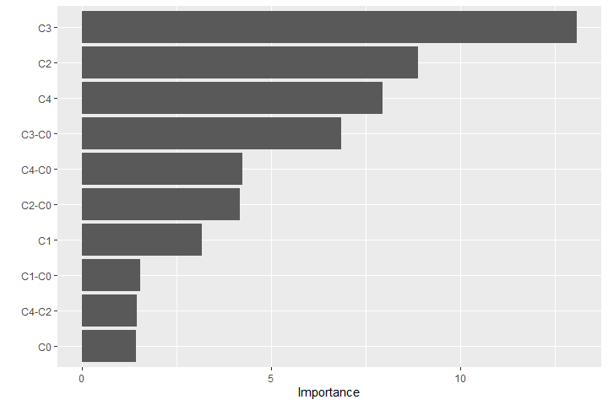

Supplementary Figure 2
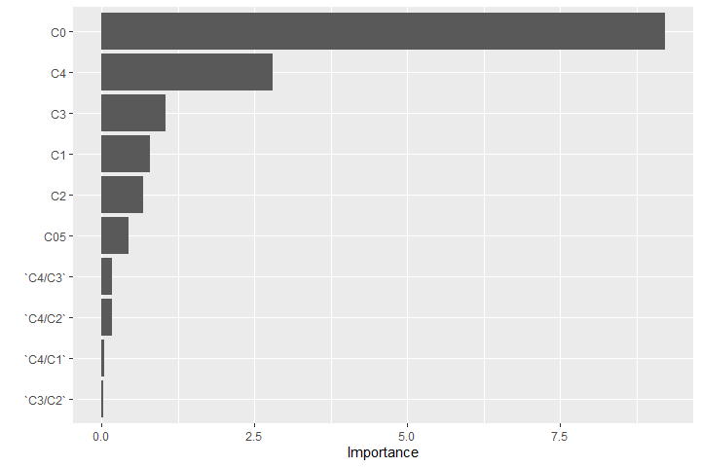

REFERENCES
1. Breiman L Random Forests. Machine Learning. 2001;45:5–32. https://doi.org/10.1023/A:1010933404324
2. Friedman JH, Hastie T, Tibshirani R Regularization Paths for Generalized Linear Models via Coordinate Descent. Journal of Statistical Software. 2010;33:1–22. https://doi.org/10.18637/jss.v033.i01
3. Kursa MB, Rudnicki WR Feature Selection with the Boruta Package. J Stat Soft. 2010;36:1–13. https://doi.org/10.18637/jss.v036.i11

